

How to make a medical mask

Thank you for helping us provide personal protective equipment (PPE) to our health care workers. Our PPE supply situation changes frequently, and normal supply continues to be disrupted.

Important reminders

- Do not make masks for donation if there is anyone in your home who:
o Smokes

o Has tested positive for COVID-19
o Has any symptoms of any respiratory illness

- Please prewash fabric, wash your hands and work in a clean environment.

- Work with the supplies you have at home.

- If you have the material for the filters, please cut but leave separate

- Please do not try the masks on.

Material list

- (2) 7 ½” x 7 ½” 100% cotton squares (pillowcase or 100% cotton quilting material with high thread count)

- (2) Elastic hair ties, make 1 cut in each to make (2) 6-7” lengths of covered elastic OR very thin 1/8” to ¼” elastic also works

- 5 ½” length of florist wire. Other wire options include:

- Plastic twist ties o Beading wire

- Pipe cleaners

Please note: Milwaukee Catholic Home (MCH) will insert filters after masks are provided.
Finished masks
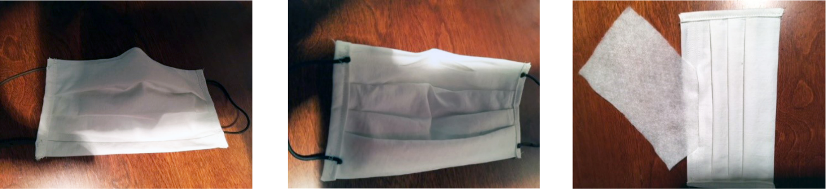

(Outside) (Inside) (Filter pocket)

Directions

Click HERE for a PDF template

Cut (2) 7 ½” x 7 ½” cotton squares
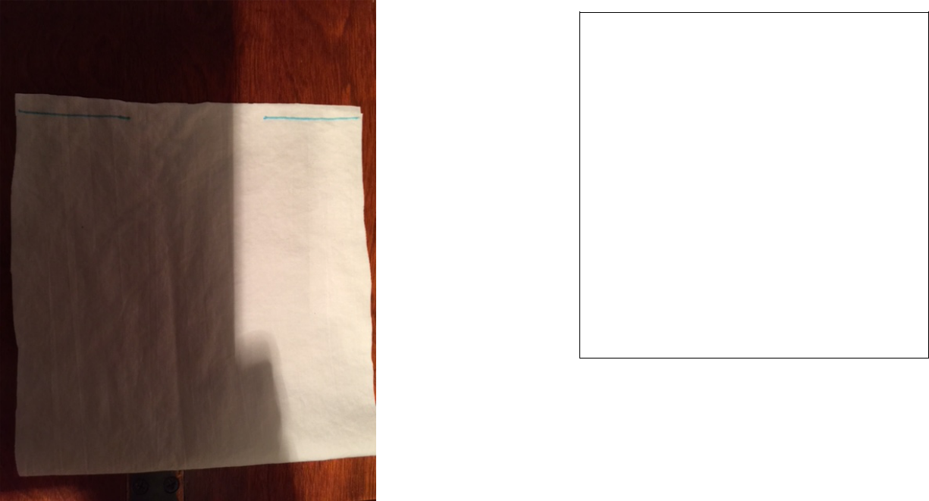

Place right sides together and at the top sew ¼” seam from edge inward toward the center 1 ½”, repeat on top from other side 1 ½”. There will be a central opening. This is where the filter will be inserted. This side of the mask is nose side or TOP

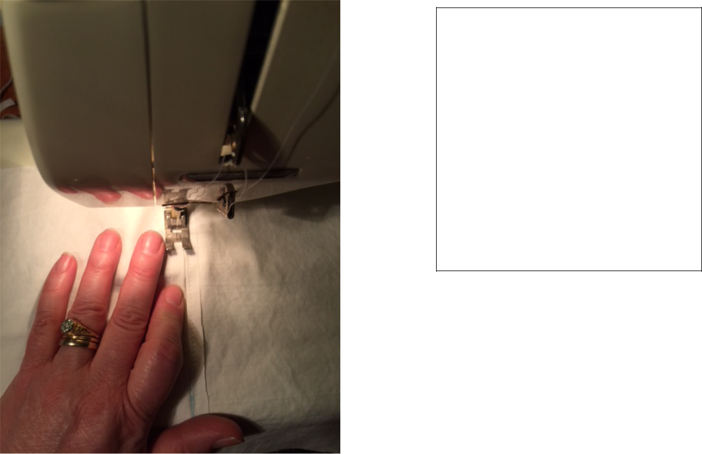
- Press top seam open, including central gap with ¼” allowance

- Top stitch both sides of seam including central opening which will be the pocket

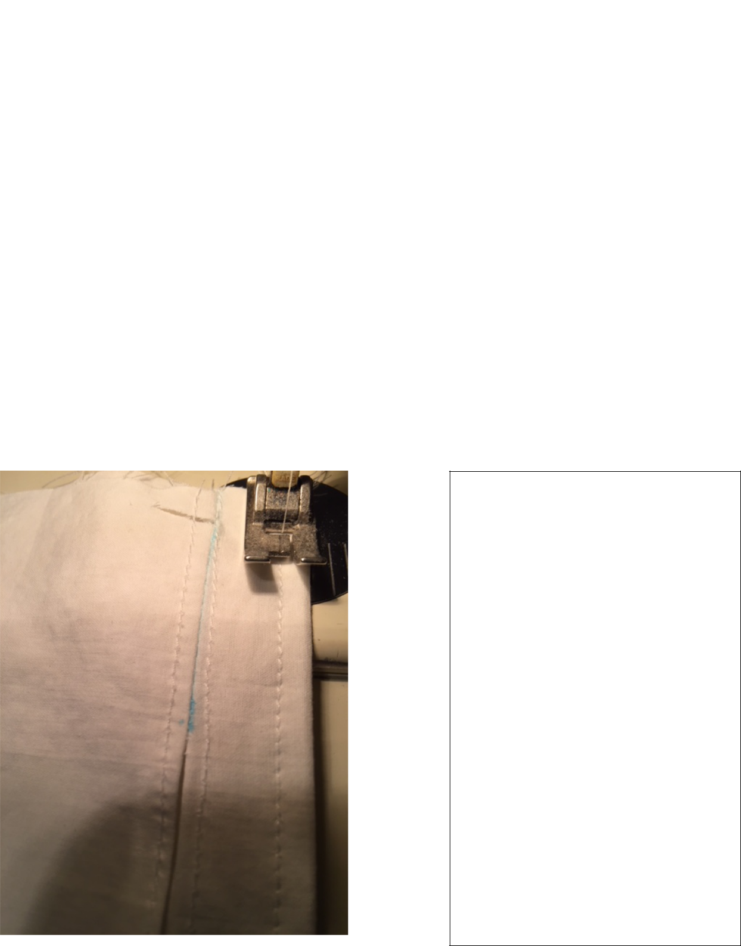

- Place right sides together and sew bottom seam (chin side) ¼”

- Turn right side out, and adjust the fabric so that there is ½” above the gap, press.

- Topstitch at top of mask near top fold ~ 1/8” from edge. This will form the casing for the crimped wire.

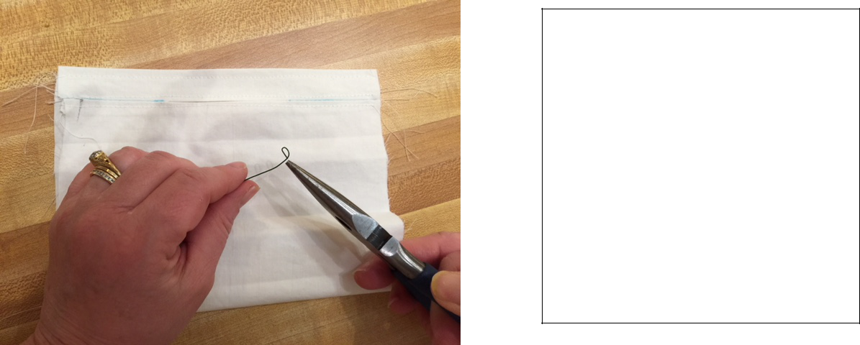
Crimp both ends of the wire into a very small circle
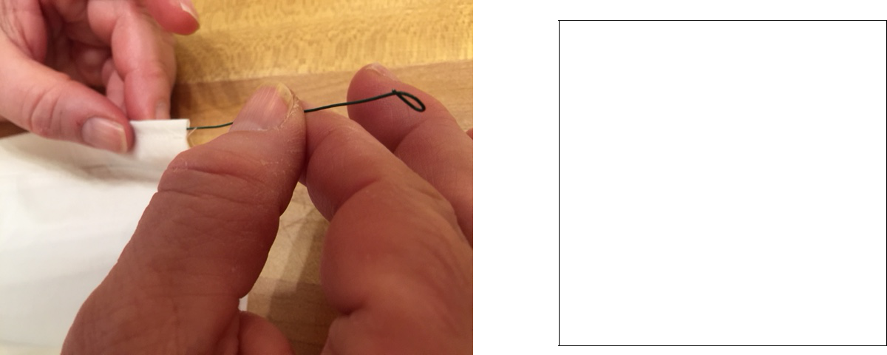

Insert and center wire in mask casing.

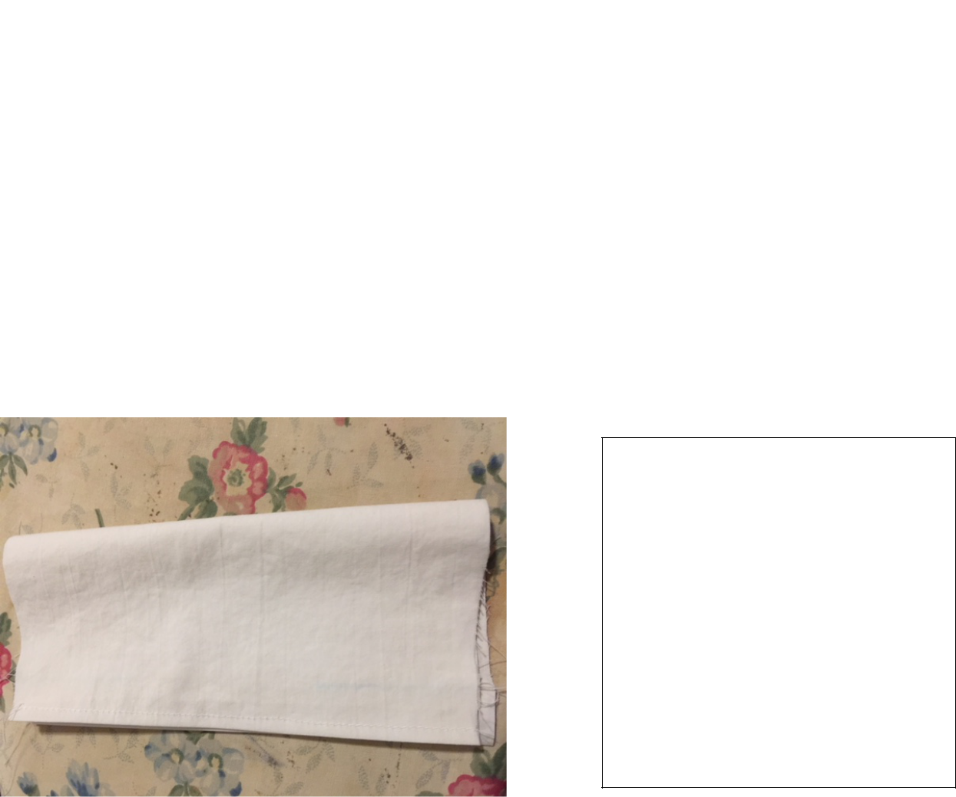

To make 3 pleats: fold mask in half so right side is out
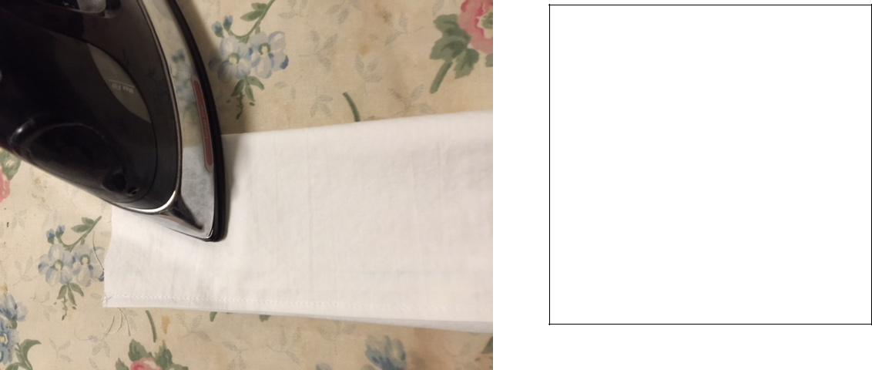
Firmly press and crease.
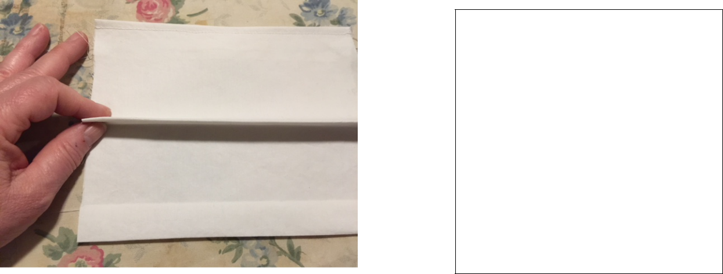

Pinch crease at each end with your fingers and fold

~ ½” downward toward chin.
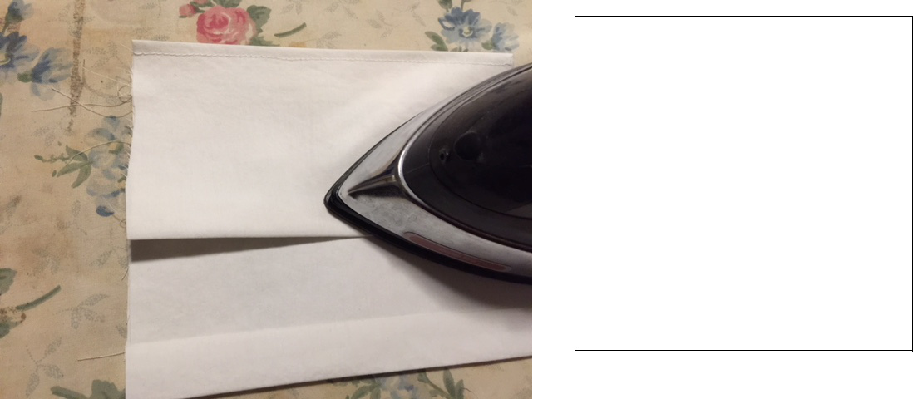

Firmly crease and press while folding down toward chin.
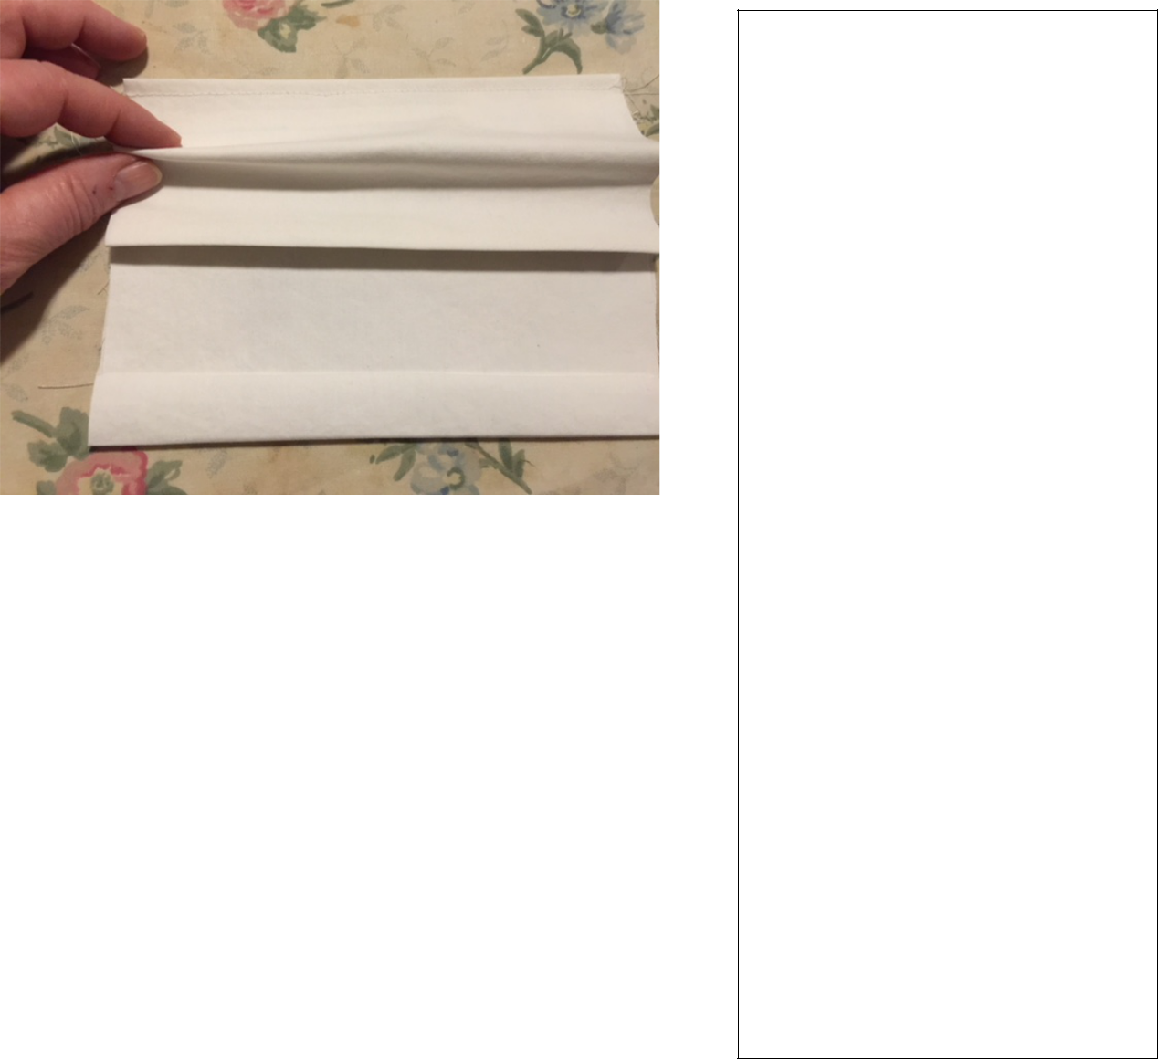

Repeat pleats above and below middle pleat by pinching ~ ½” of fabric to make a parallel fold to middle pleat (follow pattern for direction of pleats and approximate spacing). It does not have to be perfect and does take some practice.

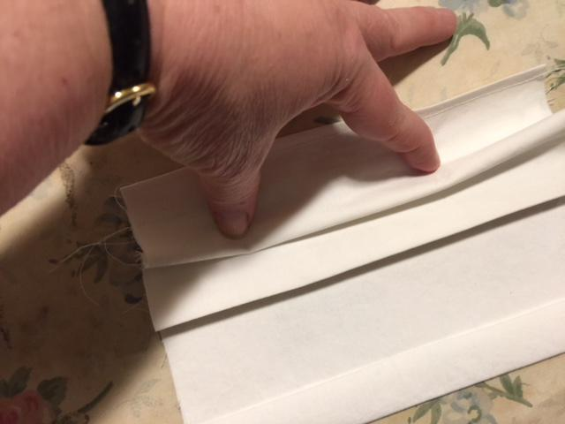
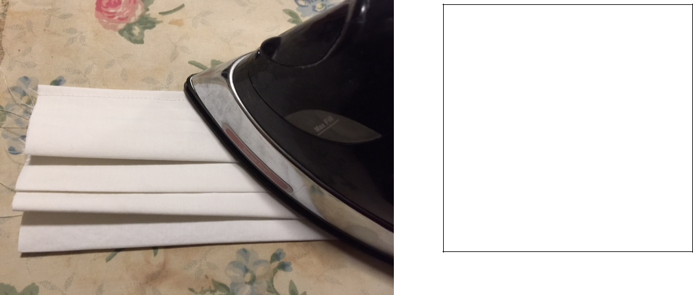
Remember to firmly press and crease each pleat and then pin sides to hold pleats in place.
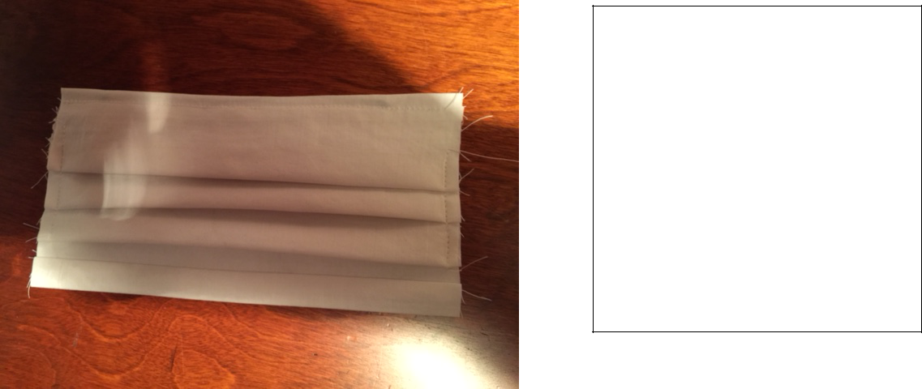

Along sides of mask, sew over pleats to secure them, ¼” from edge.

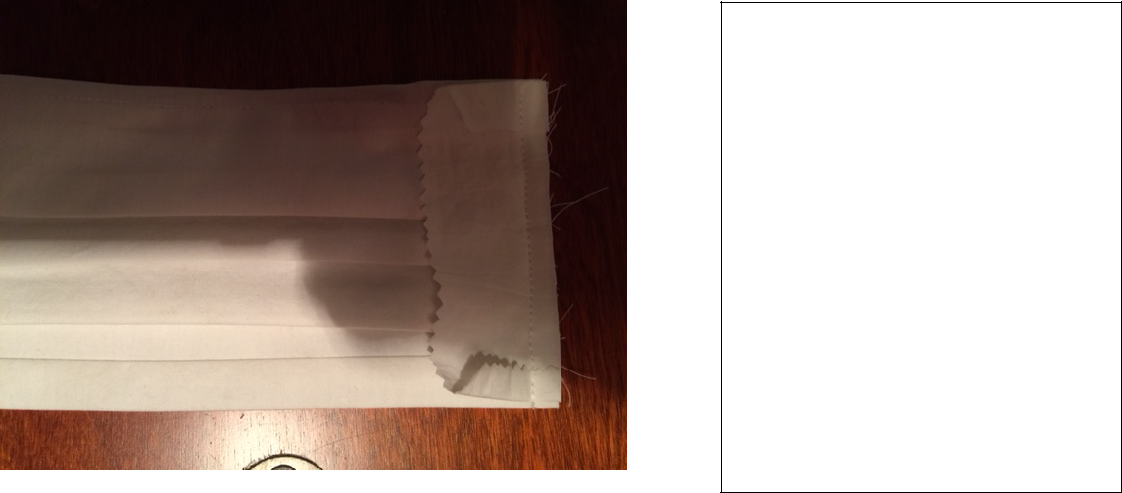
- Next, finish the sides of mask like binding tape on a quilt edge. Make two 1 ¼” strips of fabric about 1” longer than sides. Fold edges ~ ¼” to line up with top and bottom of sides. Trim as needed.

- Place strip down right side to right side of mask, lining up edges and sew ¼” seam from top to bottom.

  - Press ¼” fold

  - Wrap binding over edge to wrong side of mask.

  - Fold under raw edge ¼” and sew over fold.

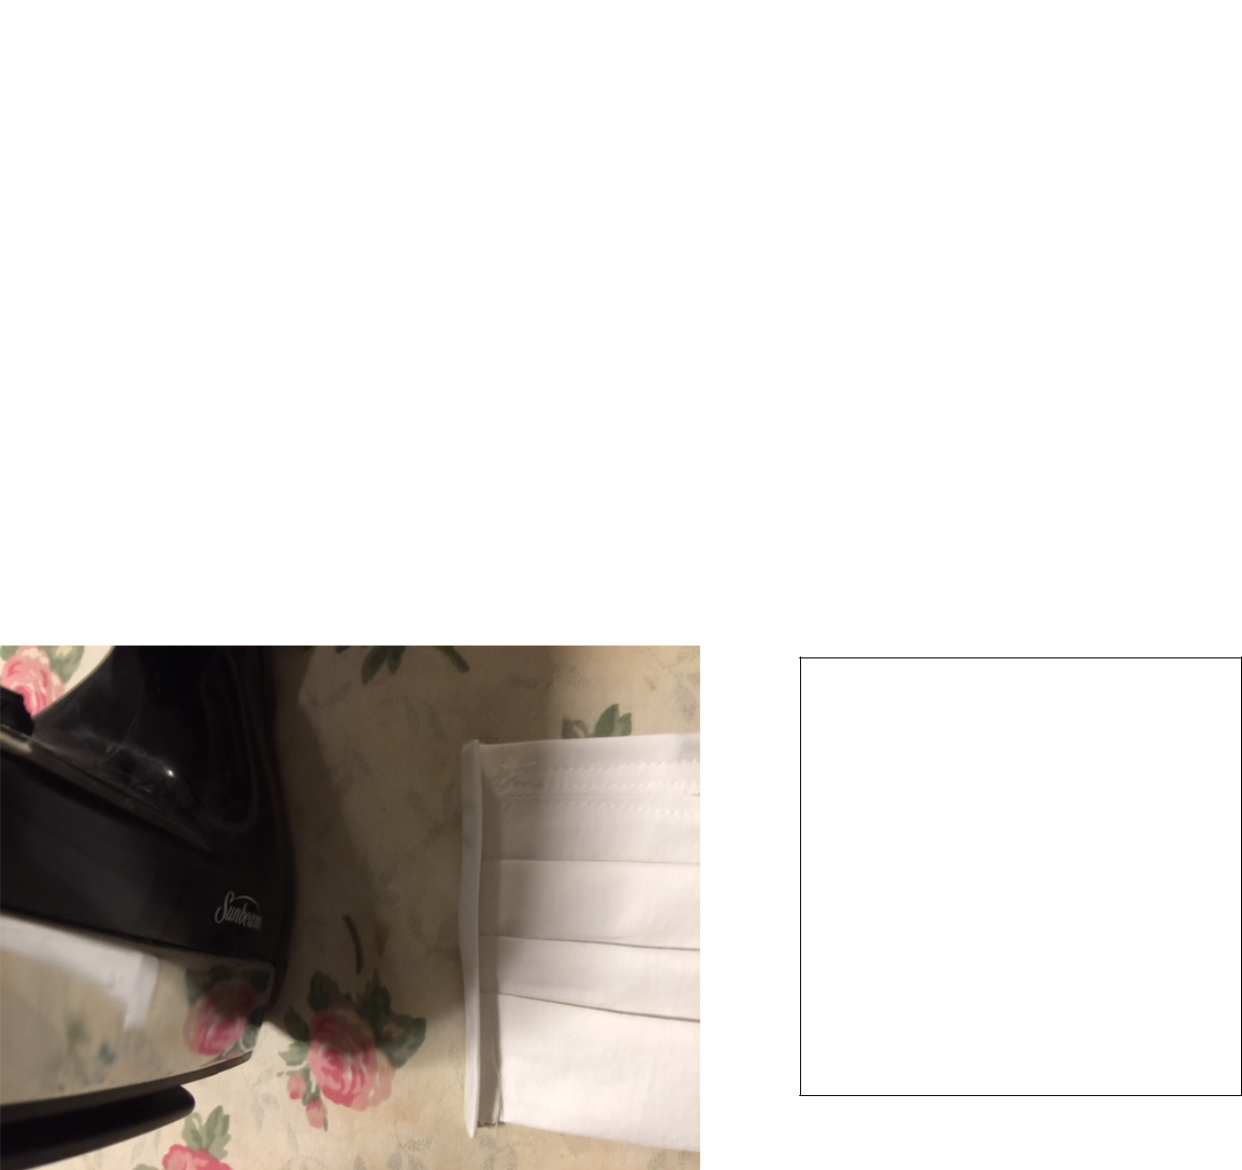
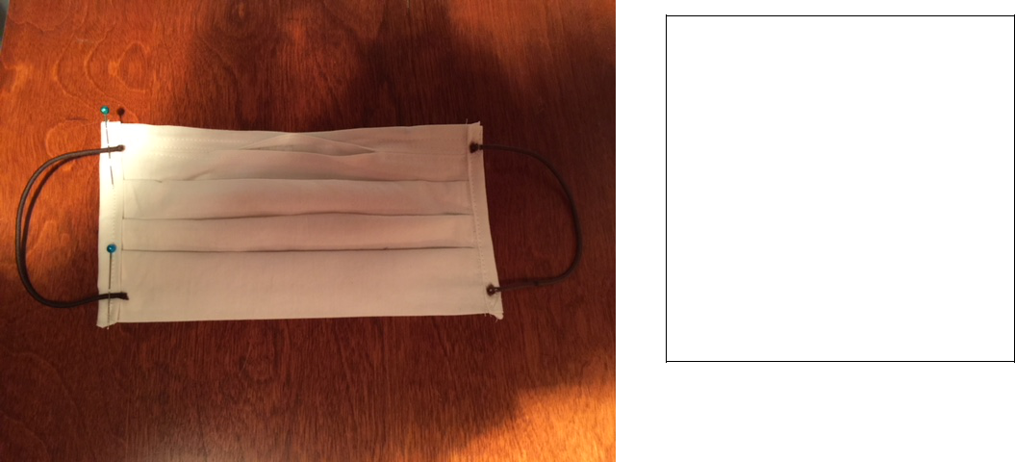
• To make elastic ear loops, snip pony tail elastic to make a 6” length. Pin elastic ½” from top and bottom, securely machine stitch back and forth over elastic

• Arrange pleats and press with iron firmly to set creases.

You are now done!

Filters will be added later at MCH. THANK YOU SO MUCH!

Please place the finished product in a plastic bag.

You can drop off the masks Monday through Friday from 1-3 p.m. at the Health and Rehabilitation Desk at 2330 North Prospect Ave Milwaukee, WI 53211. Please call Linda Cardinale at (414)220-3216 or email lcardinale@milwaukeecatholichome.org with any questions.

